

“Web-Based Vehicle and Rail Wheel Monitoring System with AI Detection”

A INTERNSHIP REPORT

Submitted by

Karthik – 20231CSE3047

Under the guidance of, Mr. Sakthi S
Assistant Professor
Presidency School of CSE
Presidency University

BACHELOR OF TECHNOLOGY IN
COMPUTER SCIENCE AND ENGINEERING

PRESIDENCY UNIVERSITY BENGALURU
MARCH 2026


PRESIDENCY SCHOOL OF COMPUTER SCIENCE AND ENGINEERING
BONAFIDE CERTIFICATE

Certified that this report titled “Web-Based Vehicle and Rail Wheel Monitoring System with Object Detection” is a bonafide work of Karthik (20231CSE3047), who has successfully carried out the project work and submitted the report in partial fulfilment of the requirements for the award of the degree of Bachelor of Technology in Computer Science and Engineering during the academic year 2025–2026.

Mr. Sakthi S Project Guide Assistant Professor PSCS
Presidency University
Ms. Vidya R
Program Internship Coordinator
PSCS
Presidency University
Dr. Md Ziaur Rahman Internship Coordinator
PSCS
Presidency University
Dr. Blessed Prince
Head of the Department PSCS Presidency University

Dr. Shakkeera L Associate Dean PSCS
Presidency University

Dr. Duraipandian N
Dean
PSCS & PSIS
Presidency Univer
Name and Signature of the Examiners

SL no | Name | Signature | Date
1
2

PRESIDENCY UNIVERSITY

PRESIDENCY SCHOOL OF COMPUTER SCIENCE AND ENGINEERING

DECLARATION

I, Karthik , a final year student of B.Tech in Computer Science and Engineering at Presidency University, Bengaluru, hereby declare that the project work titled “Web-Based Vehicle and Rail Wheel Monitoring System with Object Detection” has been independently carried out by me and submitted in partial fulfillment of the requirements for the award of the degree of Bachelor Of Technology In Computer Science And Engineering during the academic year 2025–2026.
Further, I declare that the matter embodied in this project has not been submitted previously by me for the award of any degree or diploma to any other institution or university.

Karthik 20231CSE3047

PLACE: BENGALURU

DATE: 06- MARCH-2026

ACKNOWLEDGEMENT

For completing this project work, We have received the support and the guidance from many people whom I would like to mention with deep sense of gratitude and indebtedness. We extend our gratitude to our beloved Chancellor, Pro-Vice Chancellor, and Registrar for their support and encouragement in completion of the project.
I would like to sincerely thank my internal guide , Mr. Sakthi S ,Assistant Professor, Presidency School of Computer Science and Engineering, Presidency University, for her moral support, motivation, timely guidance and encouragement provided to us during the period of our project work.
I am also thankful to Dr.Blessed Prince , Professor, Head of the Department, Presidency School of Computer Science and Engineering Presidency University, for his mentorship and encouragement.
We express our cordial thanks to Dr. Duraipandian N, Dean PSCS & PSIS, Dr. Shakkeera L, Associate Dean, Presidency School of computer Science and Engineering and the Management of Presidency University for providing the required facilities and intellectually stimulating environment that aided in the completion of my project work.
We are grateful to Dr. Ms. Vidya R, and Dr. Md Ziaur Rahman , PSCS Project Coordinators, Ms. Vidya R , Program Internship Coordinator, Presidency School of Computer Science and Engineering, or facilitating problem statements, coordinating reviews, monitoring progress, and providing their valuable support and guidance.
We are also grateful to Teaching and Non-Teaching staff of Presidency School of Computer Science and Engineering and also staff from other departments who have extended their valuable help and cooperation.

Karthik - 20231CSE3047

ABSTRACT

Industrial manufacturing facilities require efficient monitoring systems to ensure accurate tracking of materials and smooth operational flow. In railway wheel manufacturing units, vehicles transporting rail wheels enter and exit factory premises frequently. Traditionally, the monitoring of these vehicles and the counting of rail wheels loaded in trucks are performed manually by security personnel or inspectors at factory gates. Manual inspection methods are time-consuming, prone to human errors, and lack real-time digital records, which can lead to inefficiencies in inventory tracking and operational management.

The Web-Based Vehicle and Rail Wheel Monitoring System with Object Detection is designed to automate the process of monitoring vehicles and counting rail wheels using computer vision and artificial intelligence techniques. The system utilizes cameras installed at factory gates to capture video streams of incoming and outgoing vehicles. Using image processing and object detection algorithms implemented with OpenCV and Python, the system identifies vehicles and detects the rail wheels loaded inside the trucks. The detected wheels are automatically counted, and the information is processed through a backend server built using the Flask framework.

The architecture of the system integrates multiple components including vehicle detection, wheel detection, license plate recognition, and vehicle tracking modules. The license plate detection module extracts the vehicle registration number using optical character recognition (OCR), enabling accurate identification of vehicles entering or leaving the facility. All detection results are transmitted to the backend server through REST APIs, where the data is processed and stored in a structured SQL database. A web-based dashboard provides administrators with real-time access to vehicle records, wheel counts, entry and exit timestamps, and other monitoring details, allowing efficient tracking and analysis of factory gate activities.

The proposed system improves operational efficiency by reducing manual effort and minimizing counting errors associated with traditional inspection methods. Automated detection enables faster vehicle processing at factory gates while ensuring accurate digital records for auditing and inventory management. The integration of artificial intelligence and web technologies provides a scalable and reliable monitoring solution that can be adapted for other industrial environments where automated material tracking is required. Overall, the system demonstrates how AI-driven monitoring can enhance industrial automation, improve accuracy in logistics management, and support smarter decision-making in modern manufacturing facilities.

TABLE OF CONTENT

Sl. No. | Title | Page No.
 | Declaration | i
 | Acknowledgement | ii
 | Abstract | iii
 | List of Figures | vi
 | List of Tables | vii
 | Abbreviations | viii
1. | Introduction  - Background  - Statistics of project  - Prior existing technologies  - Proposed approach  - Objectives  - SDGs  - Overview of project report | 1-8
2. | Literature review | 9-10
3. | Methodology | 11-20
4. | Project management  - Project timeline  - Risk analysis  - Project budget | 20-26
5. | Analysis and Design  - Requirements  - Block Diagram  - System Flow Chart  - Choosing devices  - Designing units  - Standards  - Mapping with IoTWF reference model layers  - Domain model specification  - Communication model | 27-59

  - IoT deployment level
  - Functional view
  - Mapping IoT deployment level with functional view
  - Operational view
  - Other Design
6. | Hardware, Software and Simulation  - Hardware  - Software development tools  - Software code | 60-63
7. | Evaluation and Results  - Test points  - Test plan  - Test result  - Insights | 64-69
8. | Social, Legal, Ethical, Sustainability and Safety Aspects  - Social aspects  - Legal aspects  - Ethical aspects  - Sustainability aspects  - Safety aspects | 70-74
9. | Conclusion | 75-77
 | References | 78
 | Base Paper | 79
 | Appendix | 80-83

LIST OF FIGURES

Sl. No. | Title | Page No.
Fig 3.1 | The V model methodolog
Fig 3.2 | V-model methodology for Farm Fresh
Fig 3.3 | System Design
Fig 3.6 | SDLC case
Fig 3.9 | Project breakdown to tasks

LIST OF TABLES

Abbreviations

AI | Artificial Intelligence
CNN | Convolutional Neural Network
YOLO | You Only Look Once
ML | Machine Learning
IoT | Internet of Things
DB | Database
UI | User Interface
GPS | Global Positioning System
API | Application Programming Interface
HTML | HyperText Markup Language
CSS | Cascading Style Sheets
JS | JavaScript

Chapter 1 Introduction
Industrial environments rely heavily on efficient monitoring and management systems to maintain operational accuracy, safety, and productivity. In manufacturing facilities such as railway component factories, large quantities of materials are transported through trucks and heavy vehicles every day. One such critical component is the rail wheel, which is transported between different units for processing, storage, and distribution. Monitoring the movement of these vehicles and verifying the number of rail wheels loaded in them is essential for maintaining accurate inventory records and ensuring proper logistics management.

Traditionally, vehicle entry and exit at factory gates are monitored manually by security personnel or supervisors. The personnel visually inspect trucks, count the number of rail wheels loaded inside the vehicles, and record the information in registers or spreadsheets. While this approach has been used for many years, it has several limitations. Manual counting is prone to human error, especially when vehicles carry a large number of wheels. Additionally, manual monitoring is time-consuming and does not provide real-time digital records that can be used for analysis or decision making.

With the rapid advancement of artificial intelligence and computer vision technologies, automated monitoring systems have become increasingly feasible. Computer vision techniques allow machines to detect and recognize objects in images and videos with high accuracy. By using cameras installed at factory gates, video streams can be analyzed in real time to detect vehicles, identify industrial components such as rail wheels, and automatically generate digital records of the detected information.

The proposed Web-Based Vehicle and Rail Wheel Monitoring System with Object Detection aims to automate the monitoring process at industrial entry and exit points. The system uses computer vision techniques to detect vehicles and count the number of rail wheels loaded inside them. The detected information is processed through a backend server and stored in a database. A web dashboard provides administrators with real-time access to vehicle movement records and wheel count information.

By automating the monitoring process, the proposed system reduces manual effort, improves counting
accuracy, and enables digital tracking of vehicle movements. The integration of artificial intelligence with web-based technologies provides a scalable and efficient solution for industrial monitoring applications. This system can significantly enhance operational efficiency, reduce human errors, and support data-driven decision making in manufacturing environments.

Background of the Project

In large manufacturing industries, logistics management plays a crucial role in ensuring smooth production processes. Rail wheel factories handle the production and distribution of railway wheels used in railway transportation systems. These wheels are transported through trucks between different production units, warehouses, and railway maintenance facilities.

The monitoring of vehicles transporting rail wheels is an important task for maintaining accurate inventory and preventing material loss. Traditionally, this monitoring process involves manual inspection of vehicles at factory gates. Security personnel or supervisors count the number of wheels loaded in each vehicle and record the details such as vehicle number, entry time, and exit time.

However, manual monitoring systems have several limitations. Human errors may occur while counting wheels, especially when vehicles carry large quantities. In addition, manual record keeping makes it difficult to analyze historical data or track vehicle movements efficiently. The absence of automated monitoring also increases the workload on security personnel and may cause delays during vehicle entry and exit.

Recent developments in artificial intelligence and computer vision provide new opportunities for automating industrial monitoring systems. Computer vision algorithms can detect objects in images and videos, making it possible to identify vehicles and industrial components automatically. By integrating these technologies with web-based systems and databases, industries can implement automated monitoring solutions that improve accuracy and operational efficiency.

The background of this project is therefore based on the need to modernize industrial monitoring processes by replacing manual inspection methods with automated computer vision systems.

Statistics and Need of the Project

Industrial automation has become a key factor in improving productivity and reducing operational errors in modern manufacturing environments. According to industrial automation studies, automated monitoring systems can reduce human errors in inspection tasks by more than 70 percent. Additionally, digital monitoring systems allow industries to maintain accurate records and analyze operational data more effectively.

In railway component manufacturing facilities, thousands of rail wheels are transported every month between production units and storage facilities. Manual monitoring of these movements becomes increasingly difficult as production scales increase. Errors in counting or recording wheel quantities can lead to discrepancies in inventory records and may affect production planning.

The increasing availability of affordable cameras, powerful processors, and machine learning frameworks has made it possible to implement intelligent monitoring systems in industrial environments. Computer vision technology is widely used today in applications such as surveillance systems, traffic monitoring, quality inspection, and industrial automation.

The need for the proposed system arises from several challenges faced in traditional monitoring methods:

• Manual counting errors while inspecting vehicles carrying rail wheels.
• Lack of real-time monitoring and digital data recording.
• Increased workload for security personnel.
• Difficulty in maintaining accurate inventory records.
• Limited capability to analyze historical vehicle movement data.

By implementing an automated monitoring system using computer vision and web technologies, these challenges can be addressed effectively.

Prior Existing Technologies

Several technologies have been used in industrial monitoring and surveillance systems. Traditional CCTV surveillance systems are commonly installed at factory gates to monitor vehicle movements. However, these systems are primarily used for security purposes and do not provide automated object detection or counting capabilities.

Another commonly used method is manual inspection supported by digital spreadsheets or enterprise resource planning (ERP) systems. In this approach, security personnel manually record vehicle details and the number of materials transported. Although digital records are maintained, the counting process remains manual and is therefore prone to errors.

In recent years, computer vision technologies have been applied in industrial environments for tasks such as object detection, product inspection, and traffic monitoring. Object detection algorithms such as YOLO (You Only Look Once), SSD (Single Shot Detector), and other deep learning models have demonstrated high accuracy in detecting objects in images and videos.

License Plate Recognition systems have also been developed to automatically identify vehicle registration numbers using optical character recognition (OCR). These systems are widely used in parking management, toll collection, and traffic monitoring applications.

Despite these advancements, many industrial monitoring systems still rely on manual counting of transported materials. Existing systems often focus only on vehicle detection or license plate recognition without integrating automated counting of industrial components such as rail wheels.

The proposed project aims to bridge this gap by combining vehicle detection, wheel detection, license plate recognition, and web-based monitoring into a single integrated system.

Proposed Approach

Aim of the Project:
The proposed system introduces an automated solution for monitoring vehicles and counting rail wheels using computer vision techniques. Cameras installed at factory gates capture video streams of vehicles entering and exiting the premises. These video frames are processed using image processing algorithms to detect vehicles and identify the rail wheels loaded inside them.

The system architecture consists of multiple modules that work together to perform the monitoring process. The vehicle detection module identifies trucks approaching the factory gate. Once a vehicle is detected, the wheel detection module analyzes the video frames to detect circular shapes corresponding to rail wheels and counts them automatically.

In addition to wheel detection, the system includes a license plate recognition module that extracts the vehicle registration number using OCR techniques. The detected information, including vehicle number, wheel count, entry time, and exit time, is sent to a backend server developed using the Flask framework.

The backend processes the data and stores it in a structured SQL database. A web-based dashboard provides administrators with real-time access to vehicle records, wheel counts, and historical monitoring data. This approach enables automated monitoring, accurate counting, and efficient record management.

Objectives

The primary objective of this project is to develop an automated monitoring system capable of detecting vehicles and counting rail wheels using computer vision techniques.

The key objectives of the project include:

• Automating the monitoring of vehicles entering and exiting industrial premises.
• Detecting trucks and identifying rail wheels loaded inside them.
• Automatically counting the number of wheels transported in each vehicle.
• Implementing license plate recognition to identify vehicles.
• Storing monitoring data in a centralized database.
• Developing a web dashboard for real-time monitoring and analysis.
• Reducing manual effort and minimizing human errors in inspection processes.

1.6 SDGs

The proposed project aligns with several United Nations Sustainable Development Goals

(SDGs) related to industry, innovation, and infrastructure.

SDG 9 – Industry, Innovation and Infrastructure

The project promotes industrial innovation by integrating artificial intelligence and

computer vision technologies into industrial monitoring systems. Automated monitoring

enhances productivity and improves operational efficiency in manufacturing facilities.

SDG 8 – Decent Work and Economic Growth

By automating repetitive monitoring tasks, the system allows workers to focus on higher

level operational activities, contributing to improved productivity and economic growth.

SDG 12 – Responsible Consumption and Production

Accurate monitoring of industrial components such as rail wheels ensures better resource

management and reduces losses caused by manual counting errors.

  - Overview of project report
This project report presents the design, development, and evaluation of the Web-Based Vehicle and Rail Wheel Monitoring System.
Chapter 1: Introduces the background of the project, the need for automated monitoring systems, and the objectives of the proposed solution.
Chapter 2 : Presents a detailed literature review of existing research and technologies related to computer vision, industrial monitoring, and object detection systems.
Chapter 3 : Explains the methodology used in the project, including the development approach, system design, and implementation strategies.
Chapter 4 : Discusses project management aspects such as planning, risk analysis, and project scheduling.
Chapter 5 : Describes the system analysis and design, including hardware requirements, software architecture, and system workflow.
Chapter 6 : Presents the implementation details of the developed system, including the technologies used and system modules.
Chapter 7 : Evaluates the performance of the system through testing and analysis of results.
Chapter 8 : Discusses the social, ethical, and sustainability aspects associated with the system.
Chapter 9 : Concludes the report by summarizing the outcomes of the project and suggesting possible future enhancements.
.

Chapter 2
Literature review
In 2024, Hamid M. El-Hage and co-authors published the research paper titled “AI-Powered Real-Time Detection of Wheel Defects in Railways Using YOLOv8.” The study focuses on improving railway safety by using advanced deep learning–based object detection techniques to automatically identify defects in railway wheels. The authors implemented the YOLOv8 algorithm, which is one of the latest real-time object detection models capable of detecting cracks, wear, and other structural defects in rail wheels from captured images. The system analyzes visual data from monitoring cameras and processes it using the trained YOLOv8 model to identify defective wheels in real time. The proposed approach provides high detection accuracy and faster monitoring, which helps railway authorities take preventive maintenance actions before serious failures occur. However, the system also has some limitations, as it requires high computational resources and powerful GPUs to process large datasets and perform real-time inference efficiently.
In 2025, researchers published the paper “A Contribution to Reliable Rail Transport: AI-Powered Real-Time Wheel Defect Detection.” The study focuses on improving railway safety by detecting defects in train wheels using artificial intelligence techniques. The proposed system uses YOLOv5 segmentation combined with an RTD Transformer model to analyze wheel images and identify defects such as cracks, wear, and deformation. The system processes captured visual data and performs real-time analysis to detect abnormal wheel conditions. The main advantage of this approach is its high precision rate of about 91% and its ability to detect wheel defects in real time, which helps in preventive maintenance of railway systems. However, the system has limitations because small or partially hidden defects may not always be detected accurately, especially when the defect area is occluded.
In 2024, the paper “Automated Track Monitoring System Using Object Detection and Ultrasonic Sensor” proposed an intelligent railway monitoring framework to detect cracks and obstacles on railway tracks. The system integrates Convolutional Neural Networks (CNN) with ultrasonic sensors to analyze track conditions. Cameras capture images of the railway track while ultrasonic sensors measure the distance and detect physical obstacles. The system processes this data to detect cracks and foreign objects on the track in real time. The main advantage of this system is that it provides accurate and real-time detection of track defects and obstacles, improving railway safety and reducing manual inspection efforts. However, the system has disadvantages such as high hardware cost and regular sensor maintenance requirements.
In 2023, researchers conducted a study titled “A Comparative Study of Machine Vision-Based Rail Foreign Object Intrusion Detection Models.” This research evaluates multiple deep learning algorithms such as CNN, Faster-RCNN, and YOLO for detecting foreign objects on railway tracks. The study compares the performance of these algorithms based on accuracy, detection speed, and robustness. Experimental results show that YOLO-based models provide faster real-time detection, while Faster-RCNN provides high accuracy for complex objects. The advantage of this research is that it identifies the most effective object detection models for railway safety systems. However, the system requires a large amount of labeled training data, which can increase development time and computational requirements.
In 2022, the paper “Intelligent Railway Surveillance Framework Based on Object Recognition” introduced a deep learning-based railway monitoring system designed to detect obstacles on railway tracks. The framework uses Faster-RCNN combined with Singular Value Decomposition (SVD) and thermal imaging techniques to improve object recognition accuracy in different environmental conditions. The system processes both visual and thermal data to identify obstacles such as vehicles, animals, or debris on the tracks. The main advantage of this system is accurate detection even in low-light or poor visibility conditions. However, the approach has limitations because the processing speed becomes slow in large-scale environments with high data volume.
In 2021, the research paper “Obstacle Detection of Rail Transit Based on Deep Learning” proposed a vision-based railway safety system for detecting objects on railway tracks. The system uses an improved YOLOv4 algorithm integrated with the CSPDarknet architecture to improve detection accuracy and speed. The model processes railway track images captured by surveillance cameras and identifies obstacles that may cause accidents. The advantage of this approach is high detection accuracy for long-distance obstacles and improved real-time monitoring performance. However, the system requires complex model training and parameter tuning, which increases the implementation difficulty.
In 2023, the paper “Detection of Wheel Polygonization Based on Wayside Monitoring and Artificial Intelligence” presented a method to detect polygonal wheel defects using machine learning techniques. The system collects vibration signals from wayside sensors placed near railway tracks and analyzes them using machine learning algorithms. By examining vibration patterns generated by passing trains, the system can detect abnormal wheel shapes and early signs of wheel damage. The main advantage is early detection of wheel defects before severe damage occurs, improving maintenance planning. However, the system requires specialized sensors and complex signal processing equipment, which increases deployment cost.
In 2025, researchers proposed the method described in the paper “Real-Time Polygonal Wheel-Rail Force Identification Using CNN.” The system uses a Convolutional Neural Network (CNN) to analyze wheel-rail interaction forces and detect abnormal patterns caused by polygonal wheels. Sensors installed near railway tracks collect dynamic force signals generated when trains pass. These signals are processed using the CNN model to identify irregular wheel behavior. The system provides real-time monitoring of wheel-rail interaction, which helps railway authorities detect mechanical issues early. However, the model requires large training datasets and high computational resources for accurate prediction.
In 2021, the paper “Intelligent Railway Foreign Object Detection Using Convolutional Autoencoder” proposed a semi-supervised learning approach for detecting unknown objects on railway tracks. The system uses a Convolutional Autoencoder model that learns normal track patterns and identifies anomalies automatically. The advantage of this method is that it can detect previously unseen objects without requiring large labeled datasets. However, compared to supervised deep learning models, the detection accuracy may be lower, especially when complex objects appear on the track.
In 2021, the paper “Automatic Rail Component Detection Based on AttnConv-Net” proposed a deep learning model for detecting rail components such as clips, bolts, and fasteners. The system uses an Attention-Based Convolutional Neural Network (AttnConv-Net) to analyze railway track images and identify critical components. This approach improves maintenance efficiency by automatically identifying missing or damaged components. The main advantage is accurate detection of rail infrastructure elements, which reduces manual inspection efforts. However, the model requires high computational power and complex training processes.
In 2018, the paper “SINet: Scale-Insensitive CNN for Fast Vehicle Detection” introduced a deep learning framework designed for vehicle detection in traffic monitoring systems. The model uses a Convolutional Neural Network with context-aware ROI pooling to detect vehicles of different sizes within images. The system performs well in multi-scale detection scenarios where vehicles appear at varying distances from the camera. The advantage of the model is efficient detection of vehicles in real-time traffic environments. However, it is not specifically designed for railway datasets, which limits its direct application to railway monitoring systems.
detection, rail wheel detection, license plate recognition, and web-based monitoring into a single platform. By automating the detection and counting process, the system reduces manual effort and improves monitoring accuracy.

In 2024, the paper “Electric Vehicle Parking Monitoring System Based on Object Detection” proposed a smart parking system that uses computer vision techniques. The system employs YOLO-based object detection algorithms to monitor parking spaces and detect the presence of vehicles. Cameras capture parking lot images and the system processes them to determine available and occupied spaces. The advantage of this approach is real-time monitoring of vehicles and improved parking management efficiency. However, the system is designed for urban parking environments rather than railway monitoring applications.
In 2025, the paper “Real-Time Railway Track Monitoring Using YOLOv8 and Embedded Systems” introduced a low-cost railway safety monitoring system. The system integrates the YOLOv8 object detection algorithm with Raspberry Pi and GPS modules to detect defects and obstacles on railway tracks. Cameras capture track images and the embedded system processes them to identify potential hazards. The main advantage is low-cost real-time monitoring using embedded hardware systems. However, the system has limited processing power due to hardware constraints, which may reduce detection speed.
In 2021, the paper “Rail Surface Defect Detection Using Deep Learning” proposed a deep learning-based method for detecting cracks and defects on rail surfaces. The system uses Convolutional Neural Networks combined with image segmentation techniques to identify defect regions in track images. The advantage of this method is accurate defect segmentation and automated inspection, which improves railway maintenance efficiency. However, the model requires high-quality images for reliable detection.
Based on existing research, there is a need to develop a Web-Based Vehicle and Rail Wheel Monitoring System with AI Detection to improve railway safety and monitoring efficiency. Traditional railway inspection methods depend on manual checking, which is time-consuming and may not detect wheel defects or track obstacles at an early stage. By using Artificial Intelligence and object detection techniques, the system can automatically detect wheel defects and foreign objects on railway tracks in real time. A web-based platform also helps store and monitor data remotely. The main research gaps include improving real-time detection accuracy, efficient database management, and reliable monitoring under different environmental conditions.

Table 2.1: Summary of Literature Reviews
Author / Year | Technology Used | Application | Limitations
El-Hage et al., 2024 | YOLOv8 Deep Learning | Railway wheel defect detection | Requires high computational resources
Schmid et al., 2025 | YOLOv5 Segmentation + Transformer | Real-time wheel defect monitoring | Difficulty detecting small or hidden defects
Kumar et al., 2024 | CNN + Ultrasonic Sensors | Railway track crack and obstacle detection | High hardware cost and sensor maintenance
Zhang et al., 2023 | CNN, Faster-RCNN, YOLO | Foreign object detection on railway tracks | Requires large labeled datasets
Sharma et al., 2022 | Faster-RCNN + Thermal Imaging | Railway obstacle detection system | Slow processing for large datasets
Chen et al., 2021 | Improved YOLOv4 + CSPDarknet | Rail transit obstacle detection | Complex model training
Johansson et al., 2023 | Machine Learning + Vibration Analysis | Wheel polygonization detection | Requires specialized sensors
Patel et al., 2025 | YOLOv8 + Embedded System | Real-time railway monitoring | Limited processing power
Li et al., 2021 | Convolutional Autoencoder | Foreign object detection | Lower accuracy than supervised models
Wang et al., 2021 | Attention-Based CNN | Rail component detection | High computational cost

The analysis of these studies indicates that integrating computer vision with web-based monitoring systems can provide an efficient and scalable solution for industrial monitoring applications.

Chapter 3 Methodology

The development of the Web-Based Vehicle and Rail Wheel Monitoring System with Object Detection
follows a structured software development methodology to ensure systematic design, implementation,
and validation of the system. In this project, the V-Model (Verification and Validation Model) is adopted
as the primary development methodology.

The V-Model is an extension of the traditional Waterfall model that emphasizes both development and
testing activities at every stage of the project lifecycle. It ensures that each development phase has a
corresponding testing phase, which improves system reliability and reduces the possibility of errors in
later stages. This approach is particularly suitable for projects where system requirements are well
defined and where verification and validation are critical.

The V-Model consists of two main phases: Verification Phase and Validation Phase. The verification
phase focuses on system design and development, while the validation phase focuses on testing and
evaluation of the developed system. The structure of the model resembles the shape of the letter "V",
where the left side represents system development stages and the right side represents corresponding
testing stages.

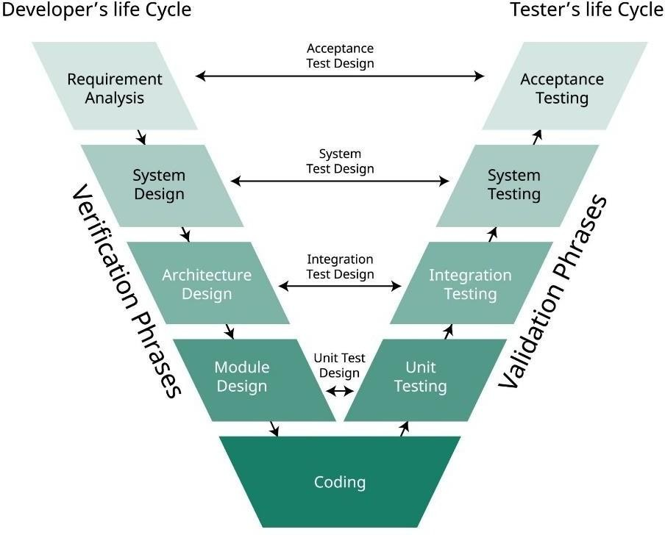
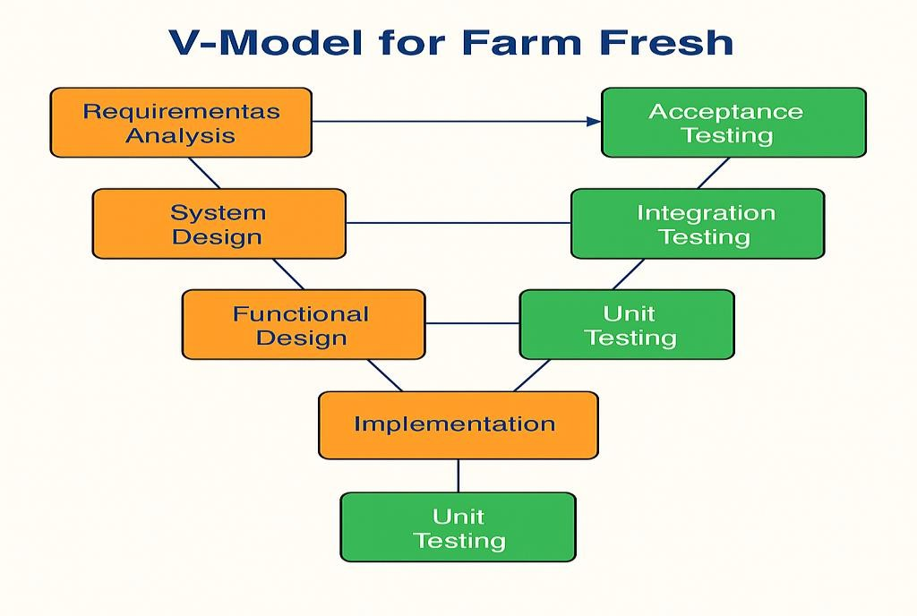
Fig 3.1 The V model methodolog

Fig 3.2 V-model methodology for Farm Fresh

MAPPING THE PROJECT TO THE V-MODEL

The development of the proposed monitoring system is mapped to different stages of the V-Model. Each phase of system development corresponds to a specific testing activity that validates the functionality implemented in that phase.

3.1.1 Requirements Analysis

The first stage in the V-Model is Requirements Analysis, where the overall objectives and functional requirements of the system are identified. In this project, the requirements analysis phase involved studying the existing monitoring process in railway wheel factories and identifying the limitations of manual inspection systems.

During this phase, the primary system requirements were defined. The system must detect vehicles entering the factory gate, identify rail wheels loaded in the vehicles, and automatically count the number of wheels present. Additionally, the system must recognize vehicle license plates and store monitoring data in a database.

The requirements analysis phase also identified the hardware and software requirements for implementing the system. Cameras are required to capture video streams of vehicles, while software tools such as Python, OpenCV, and Flask are used to implement the computer vision algorithms and backend services.

Clearly defining these requirements ensures that the system development process proceeds in a structured manner and that all essential functionalities are included.

3.1.2 System Design

After defining the system requirements, the next stage is System Design, which focuses on designing the overall architecture of the monitoring system. In this phase, the system components, modules, and interactions between different components are defined.

The proposed system architecture consists of several modules including vehicle detection, wheel detection, license plate recognition, backend processing, and database management. Cameras installed at factory gates capture video frames that are processed by the object detection algorithms implemented using OpenCV.

The system design also includes the development of a backend server using the Flask framework. The backend server receives detection results from the computer vision modules and stores them in a structured SQL database. A web-based dashboard allows administrators to monitor vehicle records and wheel counts in real time.
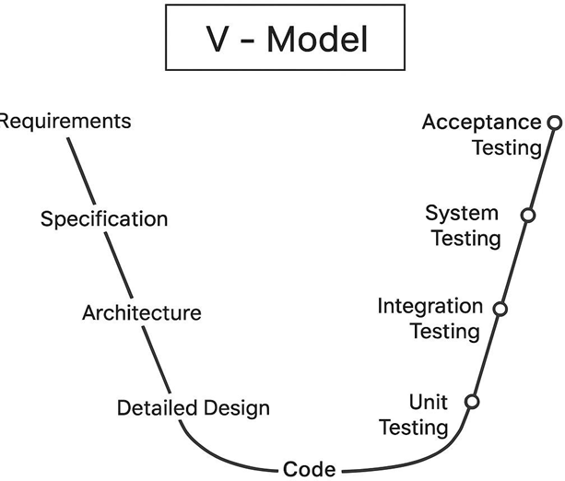

Fig 3.3 System Design

This phase ensures that all components of the system are properly structured before implementation begins.
3.1.3 Functional Design
The Functional Design phase focuses on defining how the different modules of the system interact to perform the required operations. In this stage, the workflow of the monitoring system is designed in detail.
When a vehicle approaches the factory gate, the camera captures the video feed. The vehicle detection module analyzes the frames to identify trucks entering the premises. Once a vehicle is detected, the wheel detection module processes the frames to identify circular objects corresponding to rail wheels and counts them automatically.
Simultaneously, the license plate recognition module extracts the vehicle registration number using optical character recognition techniques. The detection results are then sent to the backend server through API requests. The backend processes the data and stores it in the database along with timestamps and monitoring details.

The functional design phase ensures that each system module performs its designated role efficiently and that the overall workflow operates smoothly.

3.1.4 Unit Design
The Unit Design phase focuses on designing individual modules of the system. Each component of the monitoring system is implemented as an independent module that performs a specific function.
The main units in the system include:
• Vehicle Detection Module
• Rail Wheel Detection Module
• License Plate Recognition Module
• Backend API Module
• Database Management Module
• Web Dashboard Module
Each unit is designed and implemented separately to ensure modularity and maintainability. Modular design also simplifies debugging and testing processes during later stages of development.

VALIDATION PHASES OF THE V-MODEL
The right side of the V-Model represents the Validation Phases, which focus on testing and verifying that the developed system meets the requirements defined during the earlier stages.

3.2.1 Unit Testing
Unit testing involves testing individual modules of the system independently to verify that they function correctly. Each module developed during the unit design phase is tested separately.
For example, the vehicle detection module is tested using sample video frames to ensure that it correctly identifies trucks entering the factory gate. Similarly, the wheel detection module is tested to verify that it accurately detects circular wheel structures and counts them correctly.
Unit testing helps identify coding errors or logical issues in individual components before they are integrated with other modules.

3.2.2 Integration Testing
Integration testing verifies that different modules of the system work together correctly after being combined. In this phase, the vehicle detection module, wheel detection module, and license plate recognition module are integrated with the backend server.
The testing process ensures that detection results generated by the computer vision modules are successfully transmitted to the backend server and stored in the database. It also verifies that the web dashboard correctly retrieves and displays monitoring data.
Integration testing ensures that communication between system components is functioning properly.

3.2.3 System Testing

System testing evaluates the performance of the complete monitoring system after all modules have been integrated. In this phase, the system is tested using real-time video streams captured by cameras installed at the factory gate.
The system is evaluated based on its ability to detect vehicles, count rail wheels accurately, and record monitoring data in the database. Performance testing is also conducted to ensure that the system operates efficiently under different conditions.
System testing confirms that the entire system functions as intended and meets the requirements defined during the requirements analysis phase.

3.2.4 User Acceptance Testing (UAT)
User Acceptance Testing is the final stage of the validation process. In this phase, the developed system is tested by end users such as administrators or factory supervisors.
The users verify that the system provides accurate monitoring results and that the web dashboard displays vehicle records correctly. Feedback from users helps identify any usability issues or improvements required before deploying the system in a real industrial environment.
Successful completion of user acceptance testing confirms that the system is ready for practical use.

COMPARISON WITH OTHER METHODOLOGIES

During the planning phase of the project, several software development methodologies were evaluated, including Waterfall, Agile, Spiral, and DevOps.
The Waterfall model follows a linear development approach where each phase is completed before moving to the next. Although it is simple and structured, it does not emphasize continuous testing during development.
The Agile methodology focuses on iterative development and continuous feedback. While Agile is suitable for projects with frequently changing requirements, it may not be ideal for projects with clearly defined system architecture.
The Spiral model combines elements of both iterative development and risk management. However, it is often used for large-scale and high-risk projects that require extensive planning.
The DevOps methodology emphasizes collaboration between development and operations teams, enabling continuous integration and deployment. It is commonly used in large software systems and cloud-based applications.
Compared to these methodologies, the V-Model provides a balanced approach that integrates development and testing activities. Since the project requirements were clearly defined and required strong verification and validation processes, the V-Model was selected as the most suitable methodology for this project.

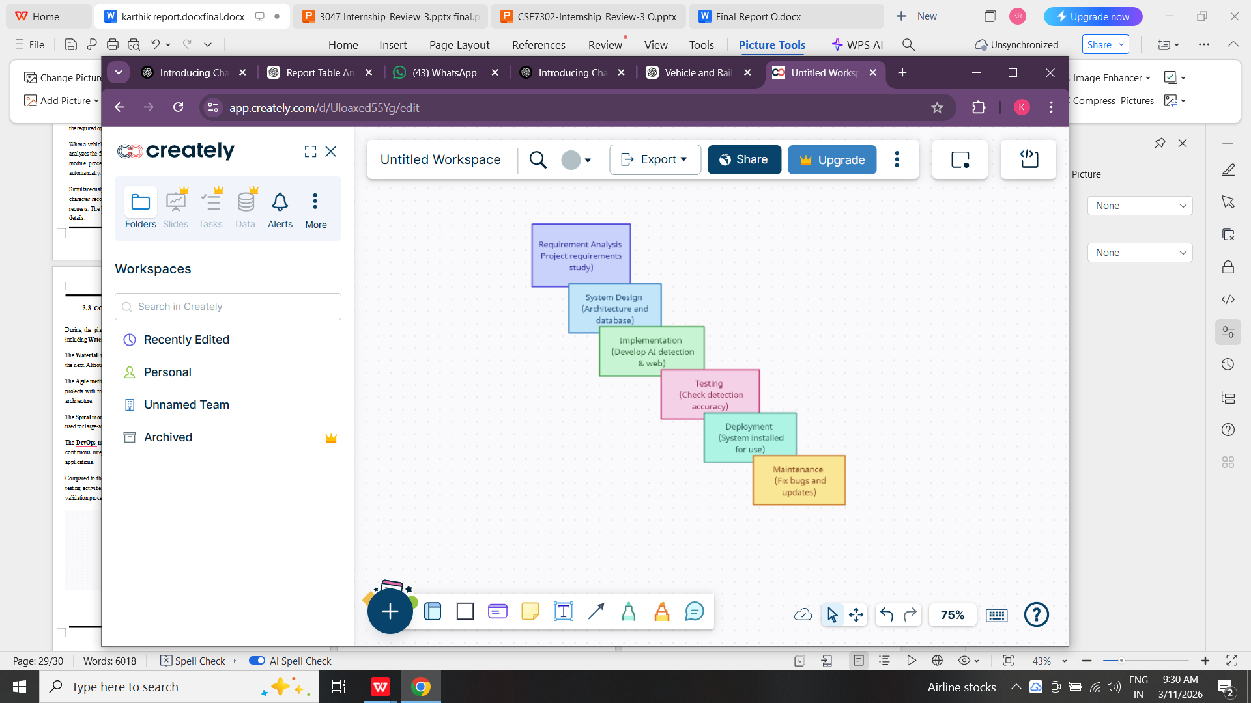

Fig 3.6 SDLC case

PROJECT BREAKDOWN STRUCTURE

The Project Breakdown Structure (PBS) summarizes how the entire project was decomposed into manageable tasks, aligning with the chosen V-Model stages.
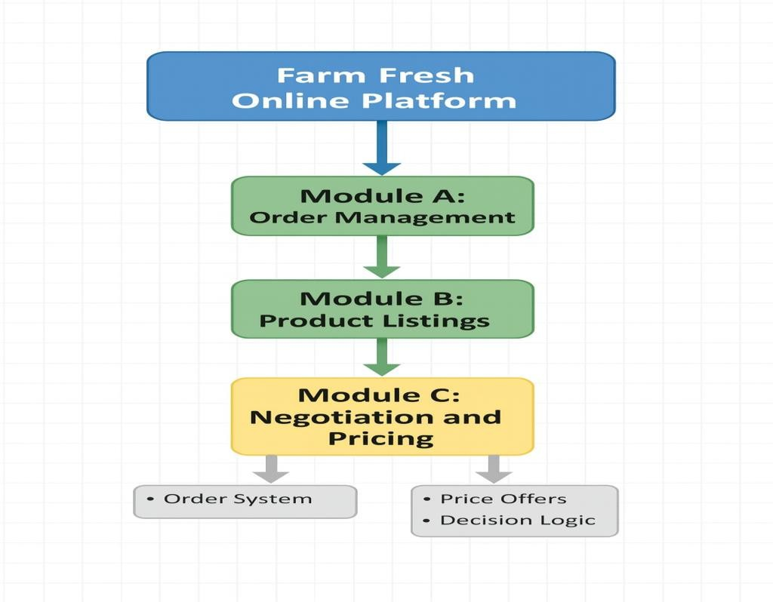
Fig 3.9 Project breakdown to tasks

The Project Breakdown Structure (PBS) divides the overall project into smaller and manageable modules. This structure helps in organizing the development process and ensures that each module is implemented systematically.
The monitoring system consists of several interconnected modules that work together to perform the required operations. The key modules include vehicle detection, rail wheel detection, license plate recognition, backend processing, and web dashboard management.
The project breakdown structure also defines the workflow between these modules. Detection modules process the captured video frames and generate detection results, which are then transmitted to the backend server. The backend stores the data in the database and updates the web dashboard accordingly.

